1. **Homeostatic control systems**

* Homeostasis: ability to regulate internal conditions within physiological ranges
* **Intrinsic** (local to organ) vs **extrinsic** (whole body, involves other organs)
* **Feedback** vs **feedforward** (act on predicted future variables)
* **Negative feedback loop** (act in opposite direction, ex: oxygen, water, pH control) vs   
  **Positive feedback loop** (act in same direction, rare, ex: action potential, clotting)
  1. **Controlled variable**: something to regulate
  2. **Sensor/receptor**: detect change in the variable from its set point
     1. Stimulus: movement of the system away from its set point
  3. **Afferent** **pathway**: send information to control center
  4. **Control center**: figure out what to do when the stimulus is detected
  5. **Efferent pathway**: send information to effector
  6. **Target/Effector**: move variable back to normal
* Negative feedback much more common
* Positive feedback loop must terminate with some distinct event
* Positive feedback can go out of control and result in pathology/pathophysiology

1. **Organ system anatomy**
2. **Molecular/chemical**: a molecule in a cell
3. **Cellular**: a cell, cells are specialized
4. **Tissue**: group of cells with similar structure and function
   1. **Muscle**: cells specialized for contracting
      1. Skeletal: striated, straight parallel lines
      2. Cardiac: striated, has intercalated discs
      3. Smooth: not striated, spindle shaped
   2. **Nervous**: cells specialized for initiating and transmitting electrical impulses
      1. Neurons: generate impulses
      2. Glial cells: support neurons
   3. **Connective**: connects, supports and anchors; few cells dispersed in lots of extracellular material
      1. Fibroblasts
   4. **Epithelial**: cells specialized in exchange of materials, 2 types
      1. Epithelial sheets: skin, stomach linings…, serve as boundaries
      2. Secretary glands: endocrine vs exocrine
5. **Organ**: 2 or more types of tissues together
6. **Organ System**: groups of organs, 11 systems - circulatory, digestive, respiratory, urinary, skeletal, muscular, integumentary, immune, nervous, endocrine, and reproductive
7. Organism
8. **Nervous versus endocrine communication systems**

* Intercellular communication: 3 methods
  + **Gap junctions** (direct, through contact)
  + Identify **surface markers** on membrane (direct)
  + Extracellular **chemical messengers** (indirect, requires diffusion or blood): **nervous** (nerves, short but fast) vs **endocrine** (blood, slow but long)
    - **Paracrine**: distribute through diffusion, local / short distance, doesn’t enter blood stream
      * Ex: histamine dilates blood vessels
    - 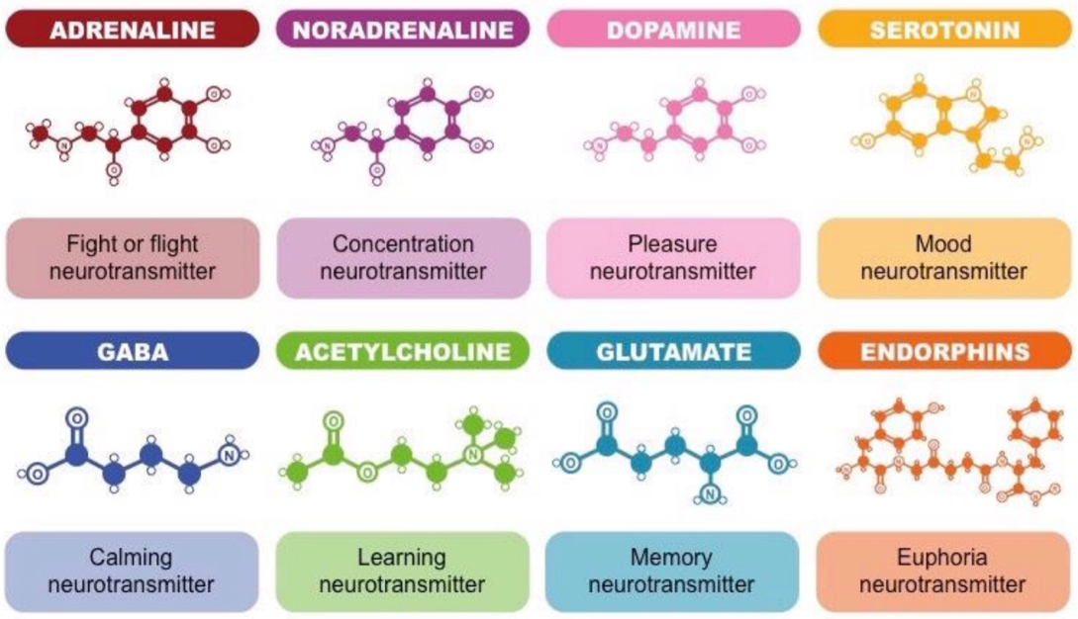**Neurotransmitters**: paracrine released by neurons (response to action potentials), also diffusion & local
    - **Hormones**: secreted into the blood by endocrine glands, long-range, only target cells of a particular hormone have receptors for it
      * Ex: steroids, peptides
    - **Neurohormones**: hormones released by neurosecretory neurons
      * Ex: oxytocin, vasopressin
* **Signal transduction** (at target cell)
  + Lipid-soluble: diffuse in
    - Ex: steroid hormones, synthesized from cholesterol
  + Water-soluble: bind to receptors
    - Ex: peptide hormones (insulin, very short half life), synthesized from precursor molecules, triggers second messengers
  + Can control chemically-gated membrane channels
  + 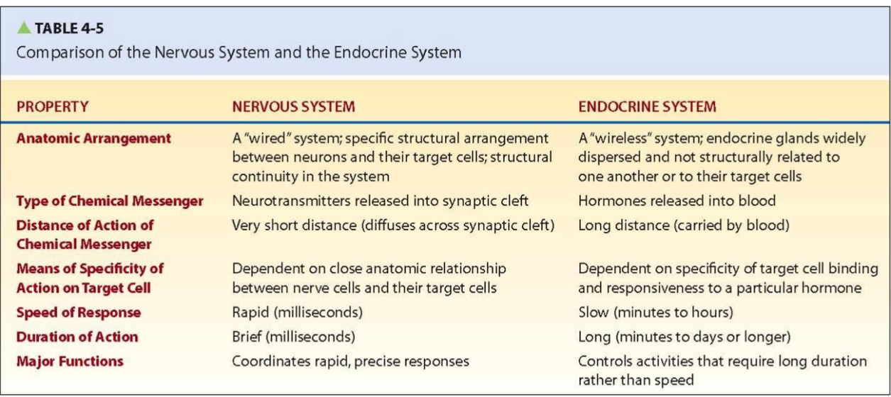First messengers can activate second messenger protein inside cell

1. 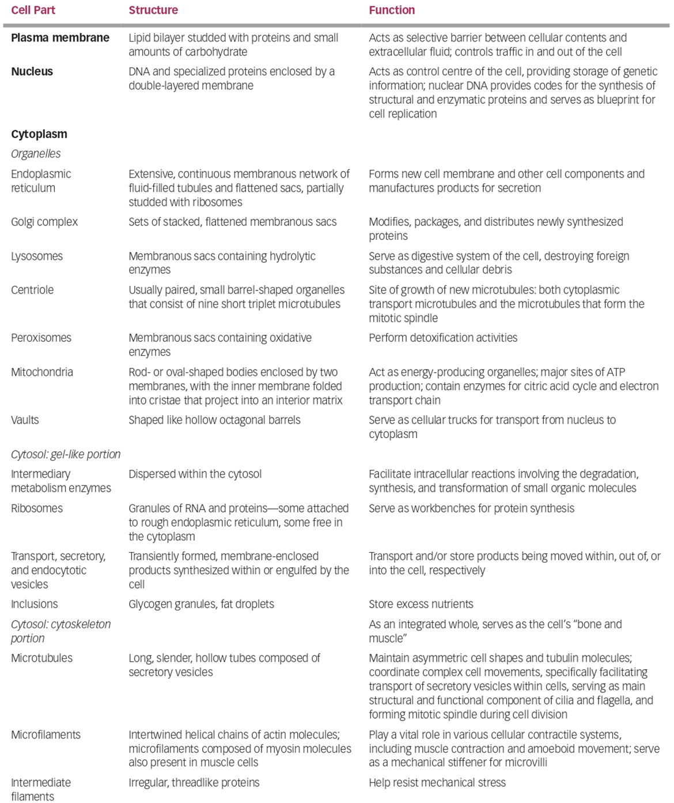**Cellular anatomy**

* Diagram

  Description automatically generatedFunctions of cells:
  + Transport nutrients
  + Eliminate waste
  + Transport
  + Produce energy
  + Grow and reproduce

1. **The plasma membrane**

* **Selective barrier**: regulates exchange of molecules with ECF, sensitivity and permeability can be altered
* **Fluid mosaic model**: model of the cell membrane with a phospholipid bilayer with proteins embedded and carbohydrates attached
  + Each phospholipid frequently exchange places with their neighbours
* **Phospholipid bilayer**: two phospholipids tail to tail
  + **Phospholipid**: like triglyceride; phosphate head (**hydrophilic**) + 2 fatty acid chains with one of them bent (one or more double bonds, **hydrophobic**)
  + **Fluidity** of this layer decides how many molecules can diffuse in/out
    - The bent leg in phospholipid makes it less tight/more fluid
    - Increase in length of the fatty acid chains decreases fluidity
    - Increase in temperature increase the fluidity
    - **Cholesterol:** gets between phospholipids, prevents stacking thus increases fluidity; balances fluidity changes from temperature
  + **Semi-permeable:** Only allows small, uncharged, nonpolar molecules (generally hydrophobic molecules) to pass through freely with the exception of water
* **Proteins**:
  + **Integral** (embedded) vs **peripheral** (floats on the surface)
  + **Transport** substance through the phospholipid bilayer, **catalyze** reactions, **bind to signal molecules** like hormones, aid **cell adhesion**
* **Carbohydrates:** attached to the proteins / lipids to form glycoproteins / glycolipids, can be used for cells to **recognize** each other
* Adhesion techniques:
  + Biological glue: connective tisssues in extracellular matrix (ECM)
  + Desmosomes: adhering (but not touching so still permeable) junctions, involves adhesion molecules cell membranes
  + Tight junctions: impermeable junctions, tightly bonded
  + **Gap junctions** (communicating junctions): connected by connexons (six protein subunits arranged in a tube)
    - Allows small, hydrophillic particles; low resistance
    - Bidirectional
* **Tonicity**: hypertonic solution => shrink, hypotonic solution => swell
  + Some molecules can’t pass through membrane, so water will move

1. 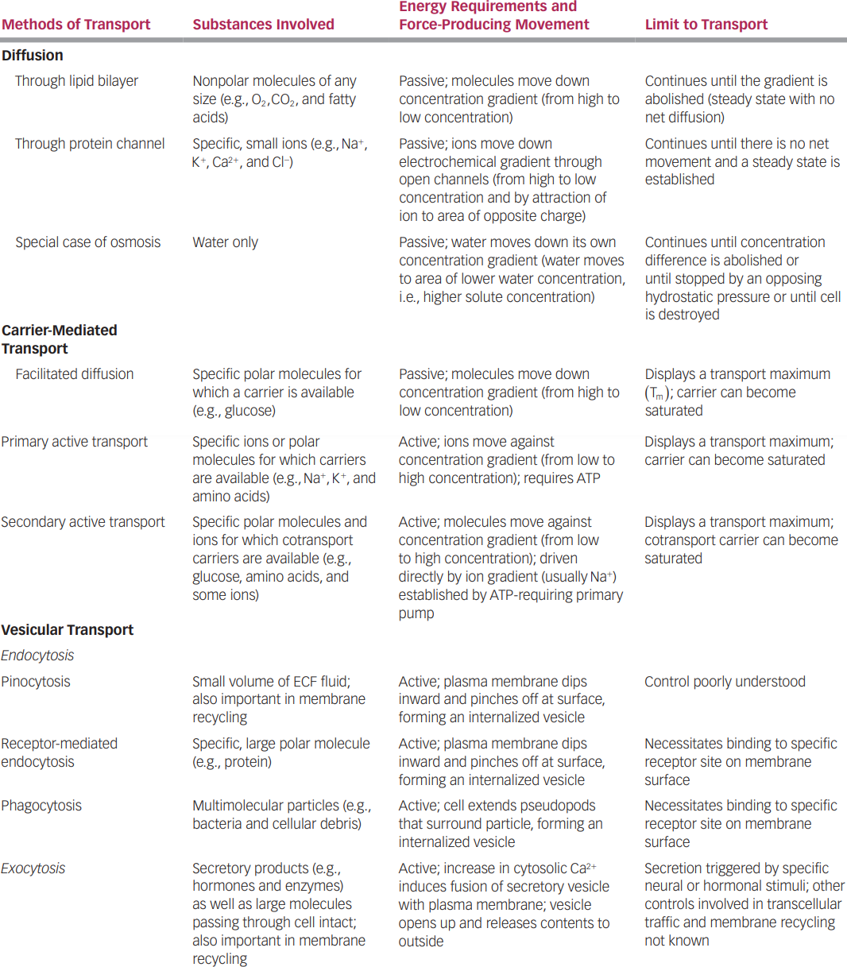**Membrane transport mechanisms**